9A: Implicit Class

scala> val strr = "Hello World!!"
val strr: String = Hello World!!

scala> strr.toUpperCase()
val res0: String = HELLO WORLD!!

scala> implicit class StringFunctionClass(s: String) {
| def firstChar() = s.substring(0,1)
| }
// defined class StringFunctionClass
def StringFunctionClass(s: String): StringFunctionClass

scala> strr.firstChar()
val res1: String = H

All the functions available to strr. are:

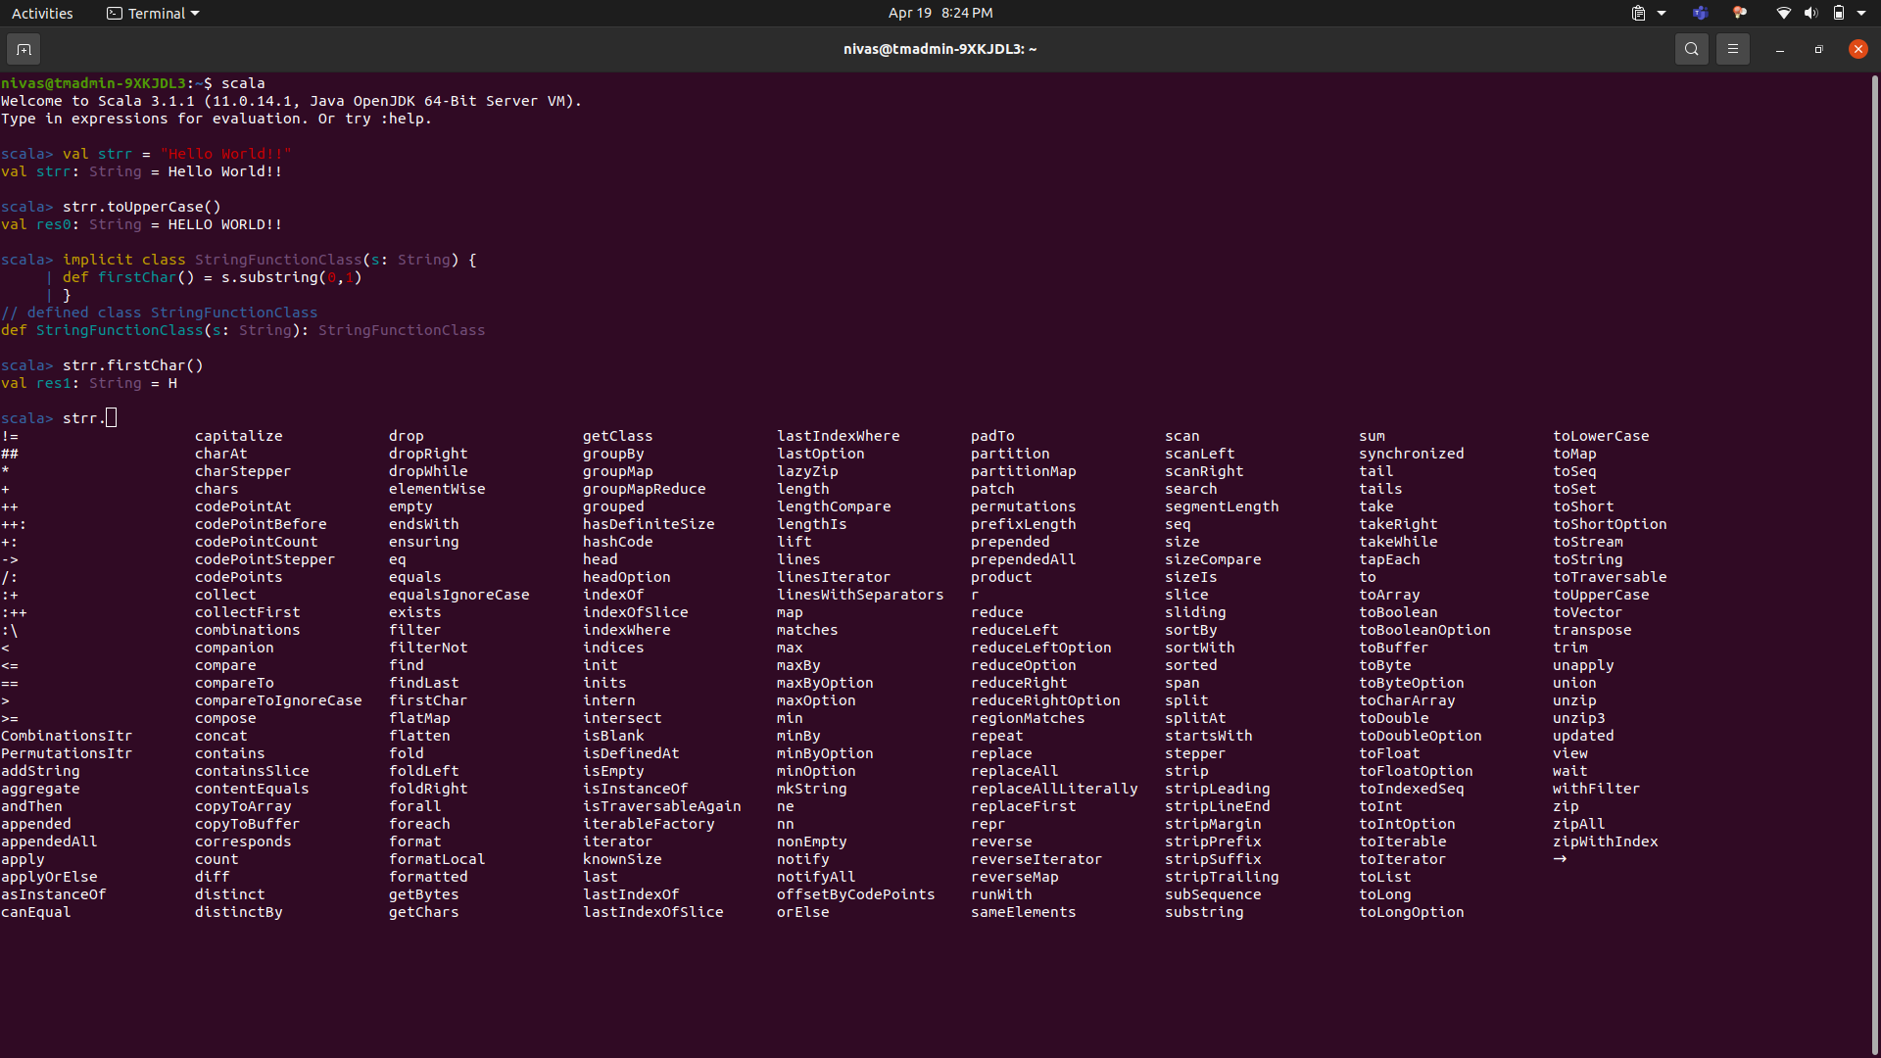
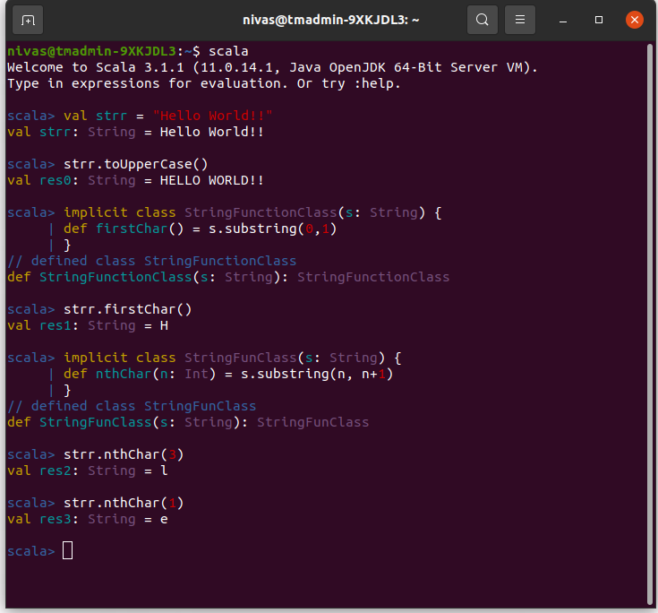
scala> implicit class StringFunClass(s: String) {
| def nthChar(n: Int) = s.substring(n, n+1)
| }
// defined class StringFunClass
def StringFunClass(s: String): StringFunClass

scala> strr.nthChar(3)
val res2: String = l

scala> strr.nthChar(1)
val res3: String = e

